Ex. No. 10 | HTML form request Handling using Nodejs and Mongodb
Date of Exercise | 09.09.2026
GitHub Host Link | https://gautham75.github.io/Web-Technology-Lab/

Aim
To develop a server-side application using Node.js to handle HTML form submissions, validate user registration details, store the submitted data in MongoDB, and retrieve and display the details in a table format.
Description
- Node.js allows you to run JavaScript outside the web browser.
- It is used to create both client-side and server-side applications ( Full Stack Web Application Development ) .
- Node.js is a single-threaded application environment.
- A single response is provided for all requests.
- Node.js is best suited for creating websites and web applications that contain fewer CPU-intensive tasks.
Sample Node.js Program for Practice
1. home.html
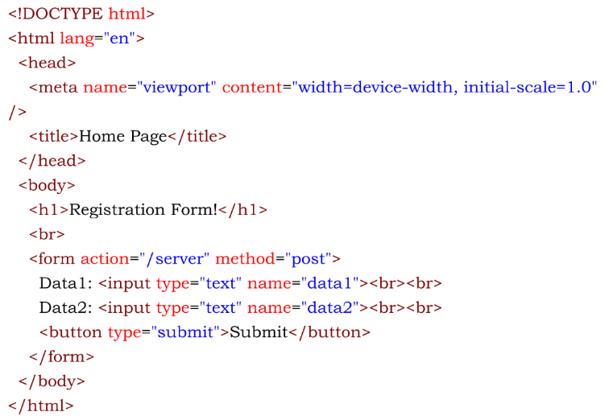
2. app.js
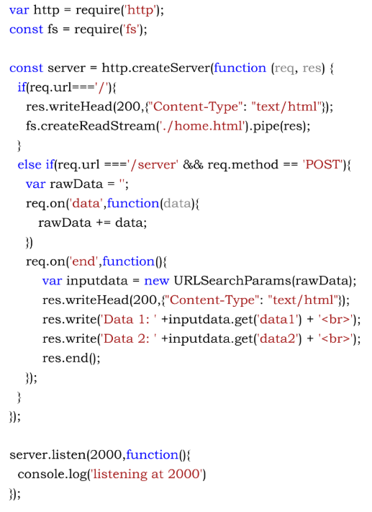
MongoDB Sample Code
var MongoClient = require('mongodb').MongoClient;
var url = "mongodb://localhost:27017/";
MongoClient.connect(url, function(err, db) {
if (err) throw err;
var dbo = db.db("mydb");
var myobj = {
name: "Company Inc",
address: "Highway 37"
};
dbo.collection("customers").insertOne(myobj, function(err, res) {
if (err) throw err;
console.log("1 document inserted");
db.close();
});
});
Sample Questions
Create a Node JS Server application for designing new user registration HTML form page and process all the HTML Form details and display the same when the form is submitted.
When the server URL is http://localhost:6000 is executed display the home page as given below [All fields are mandatory and use predefined html form validator also].
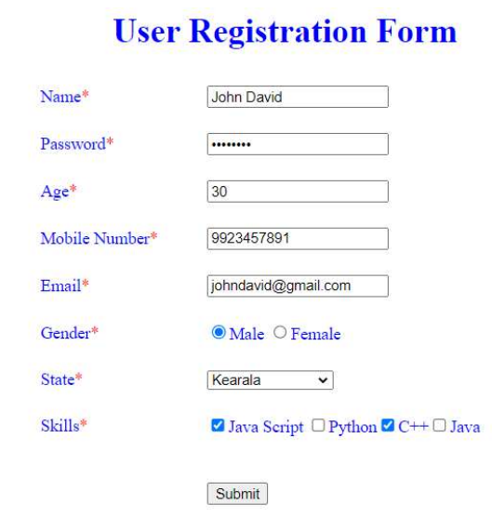
When the submit button is clicked, the URL changes to http://localhost:6000/server and should initiate storage of data from the forms to MongoDB and display the user entered details in table format as given below from database.
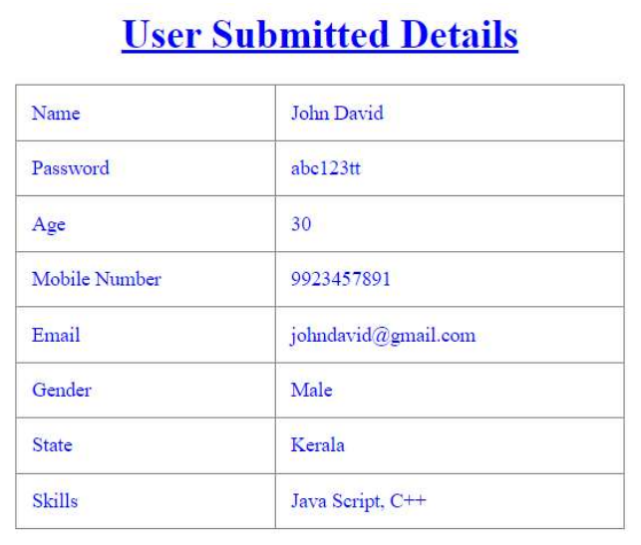
Program
1. home.html
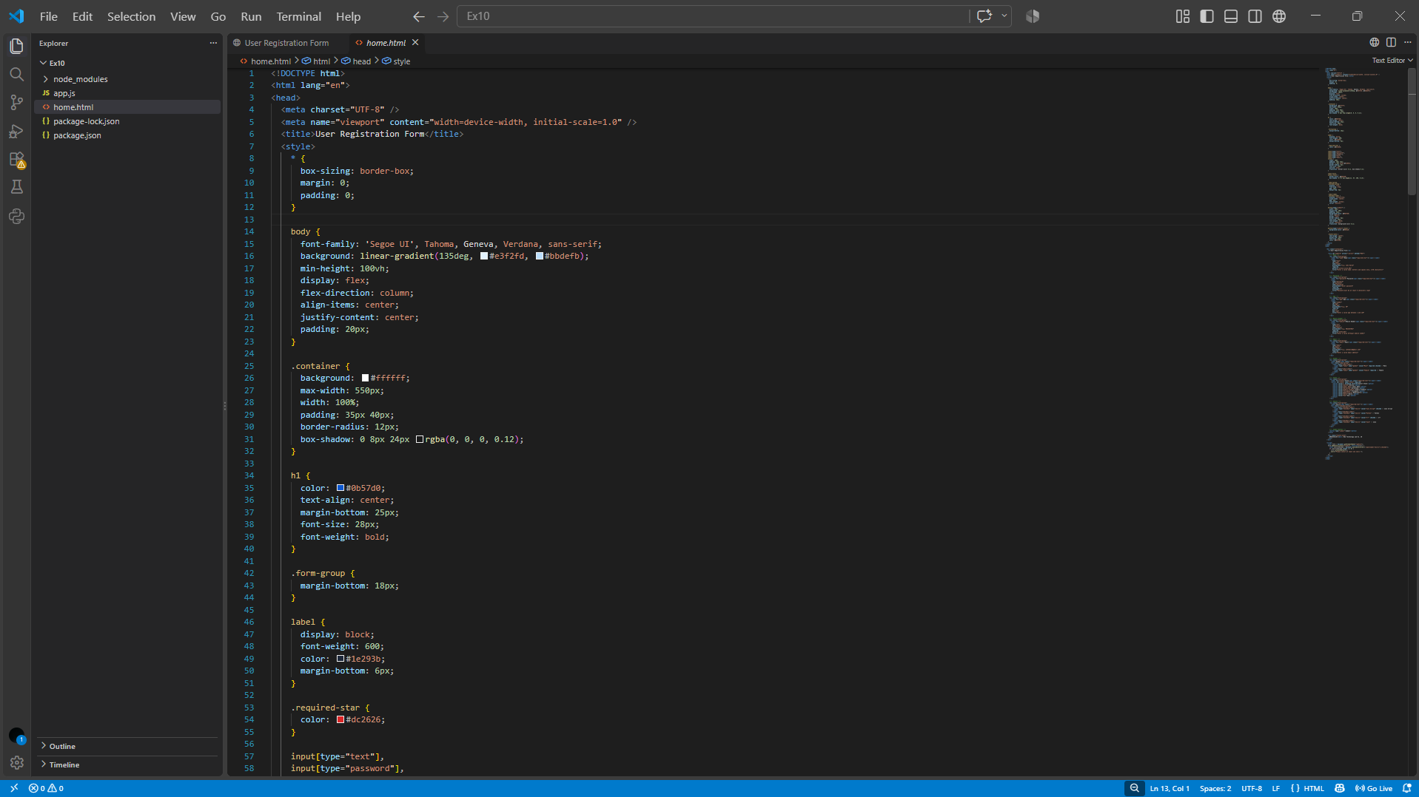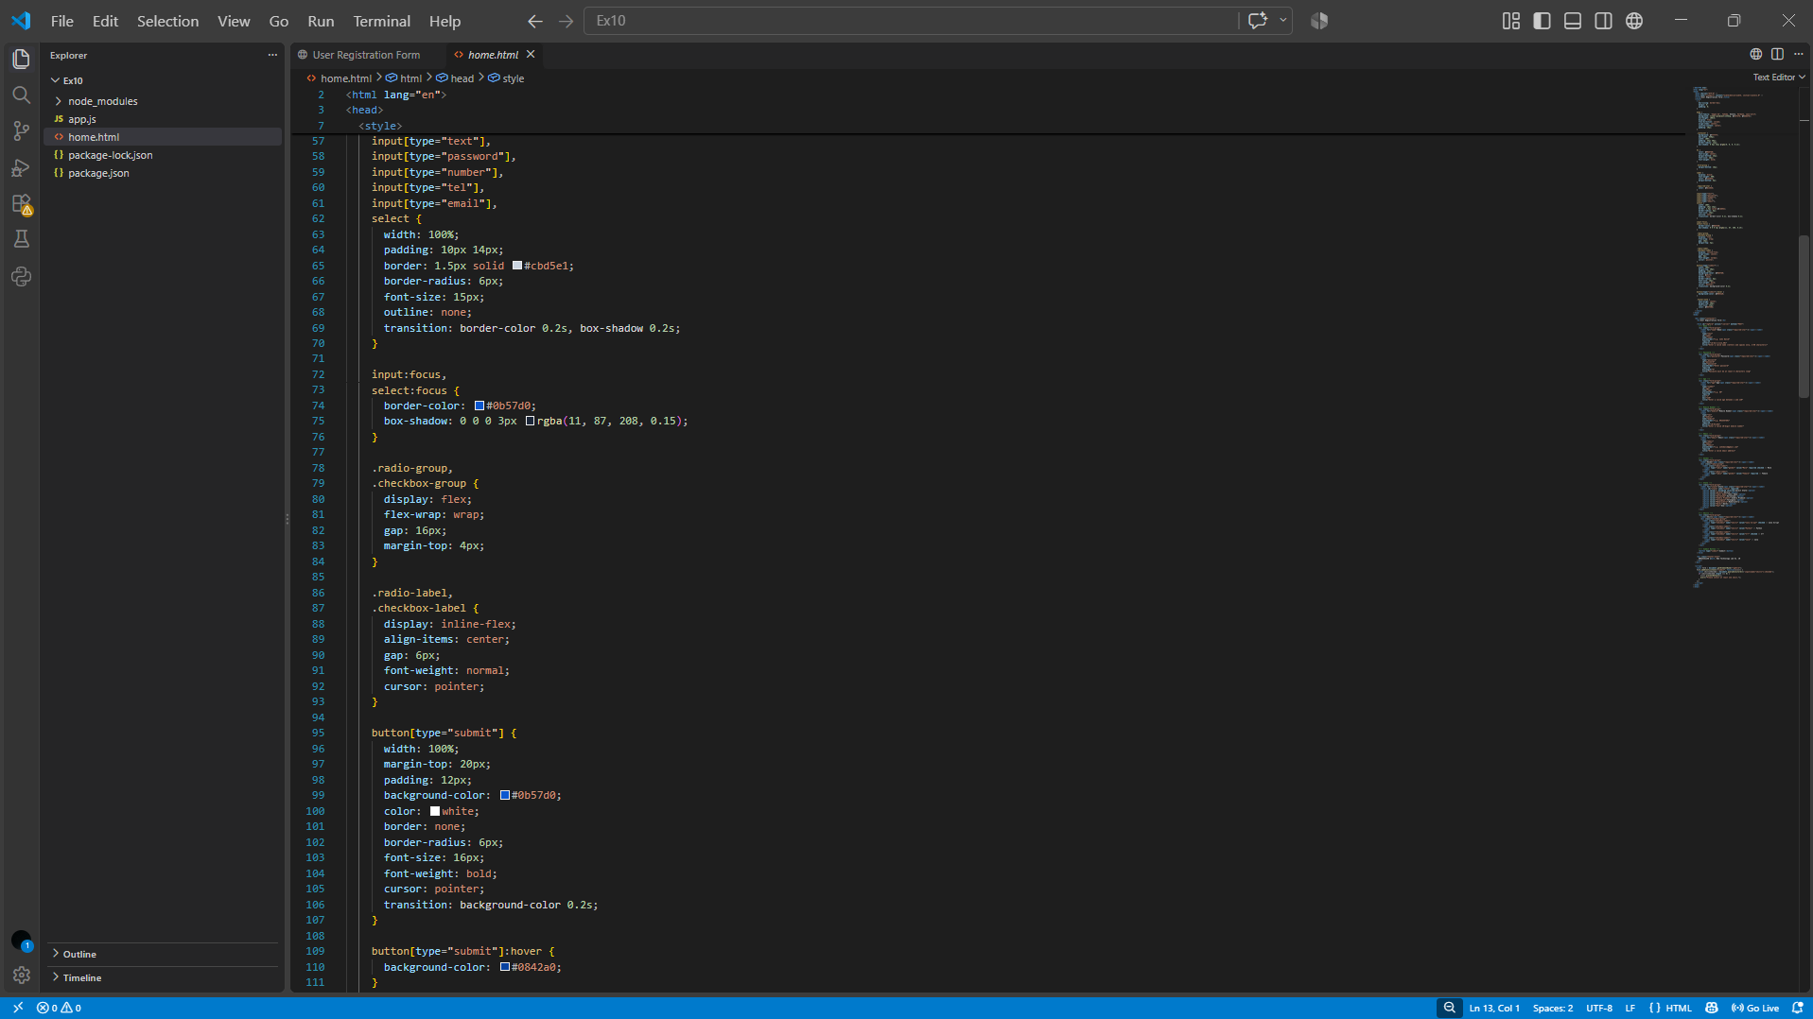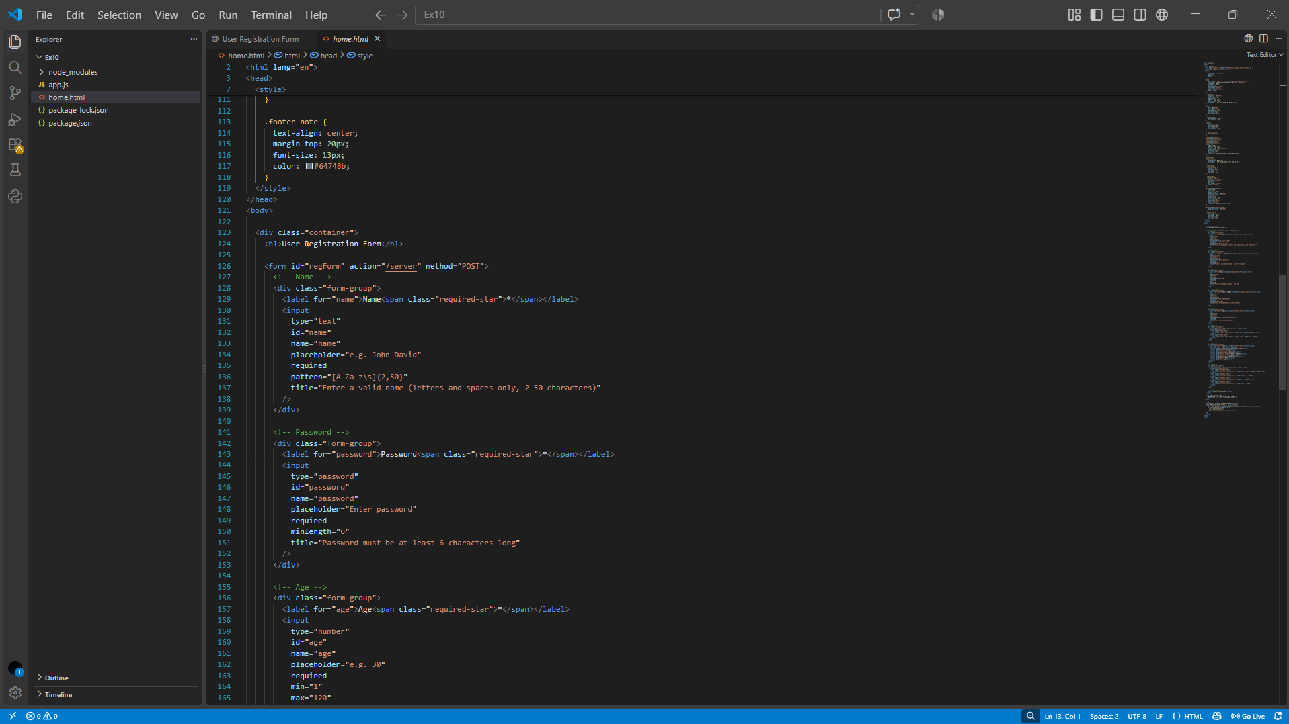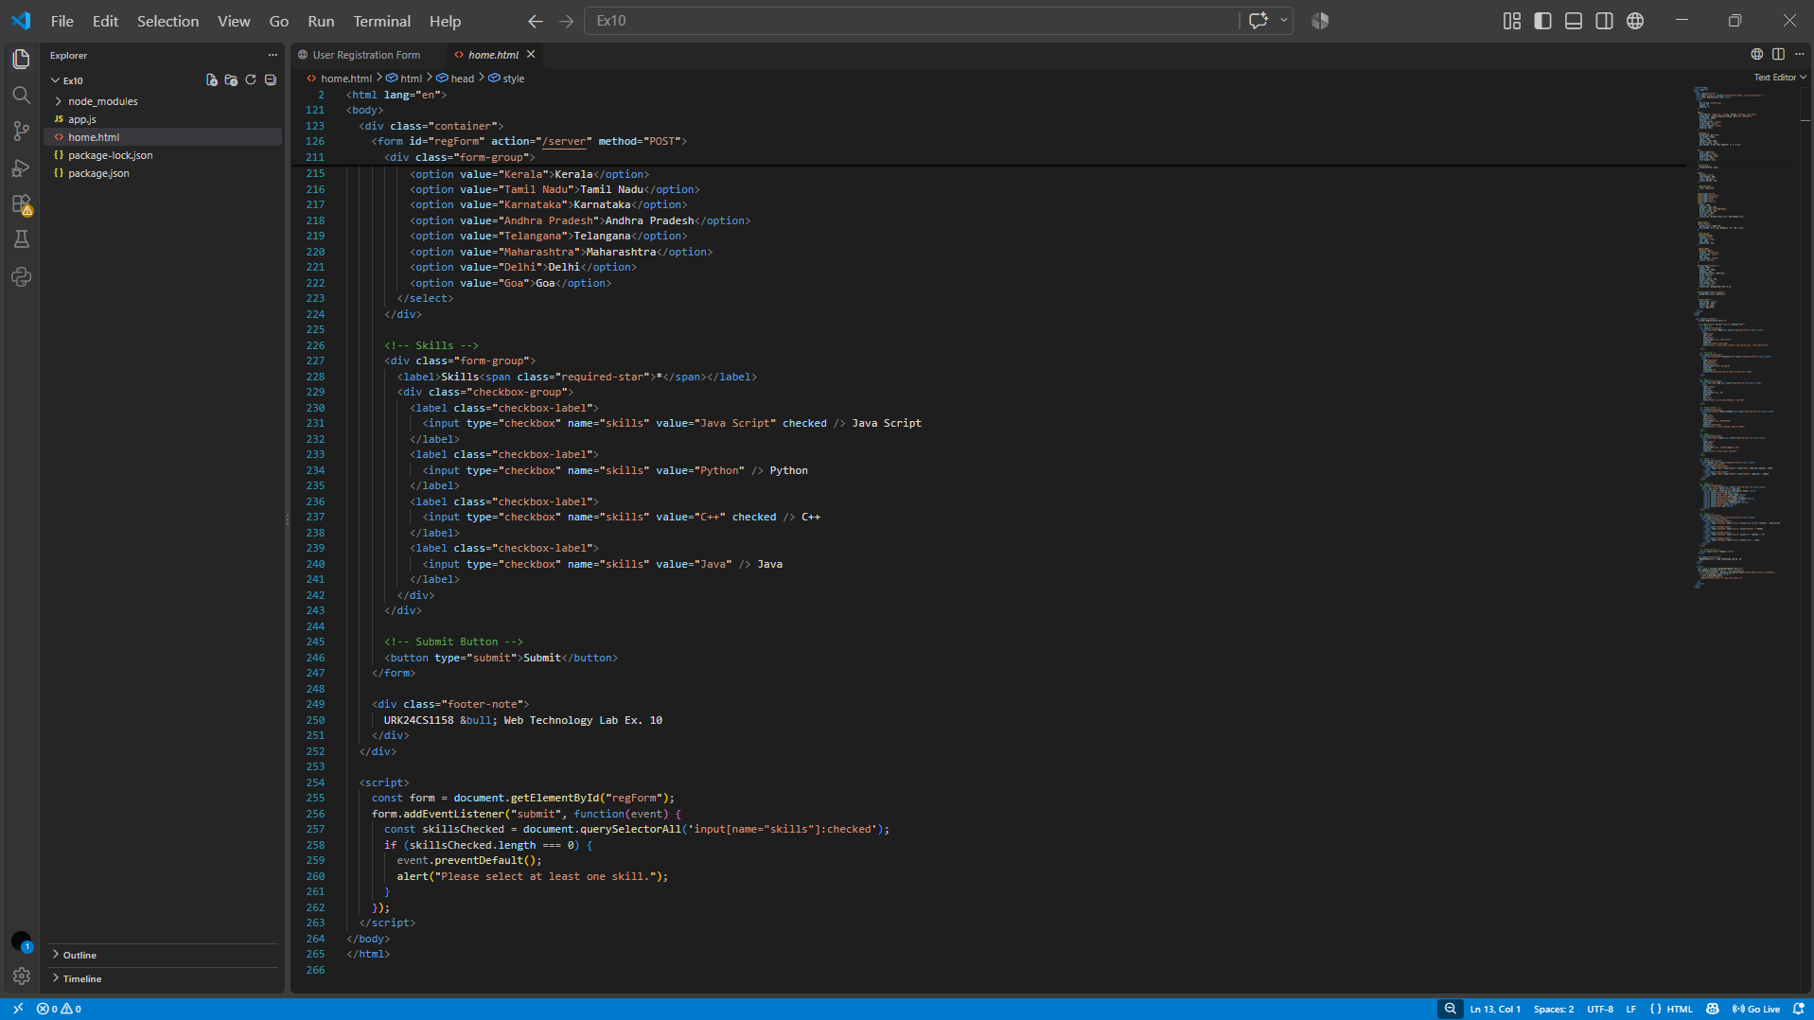

2. app.js
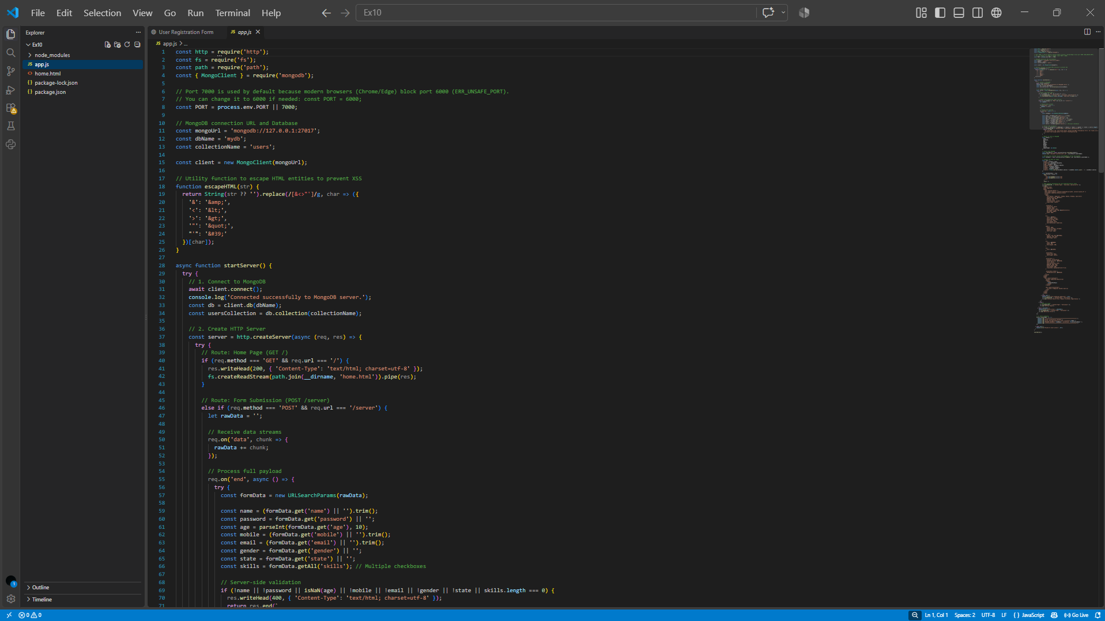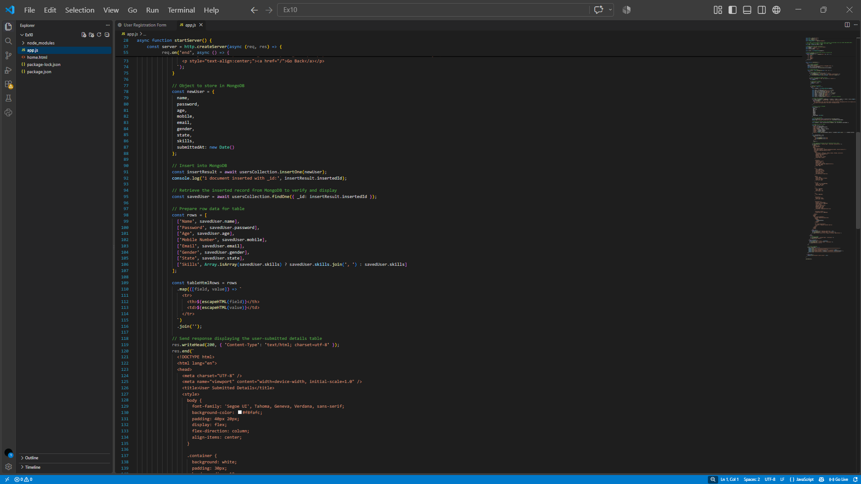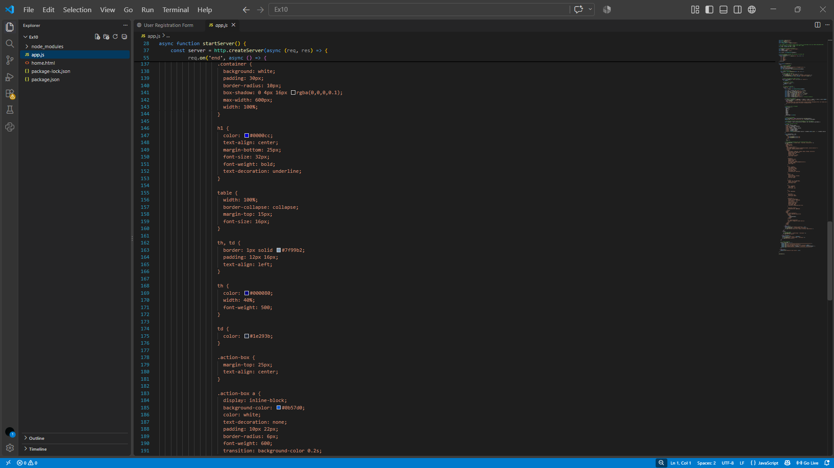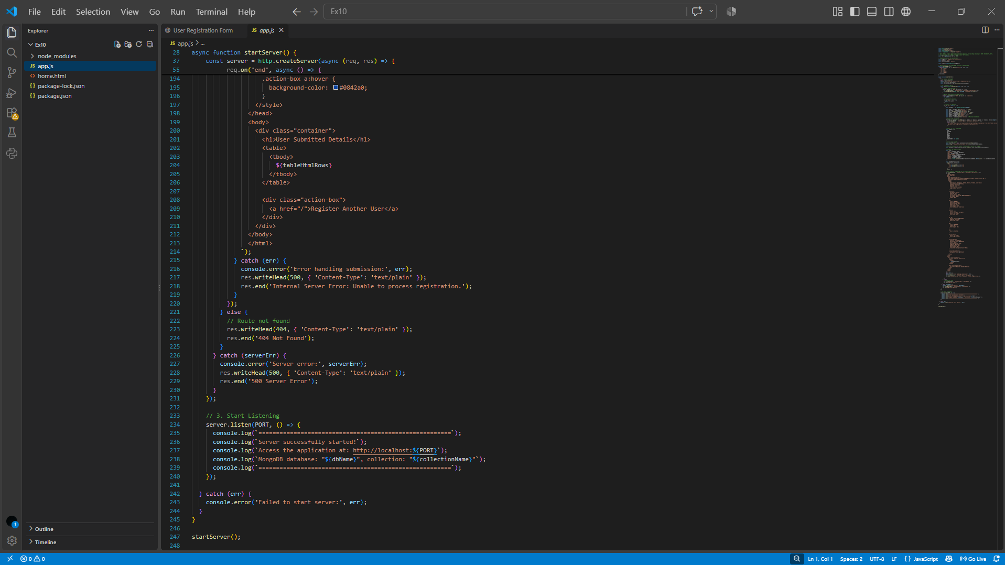

3. package.json
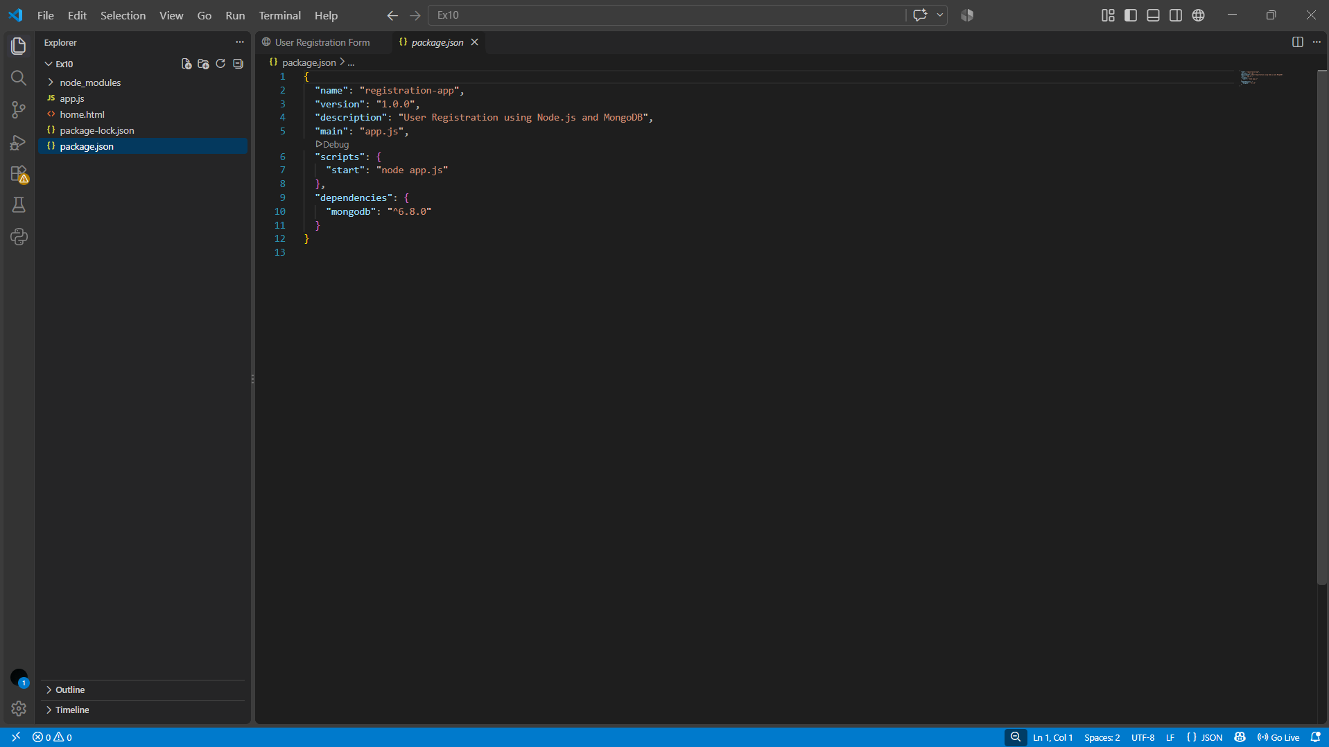
Output
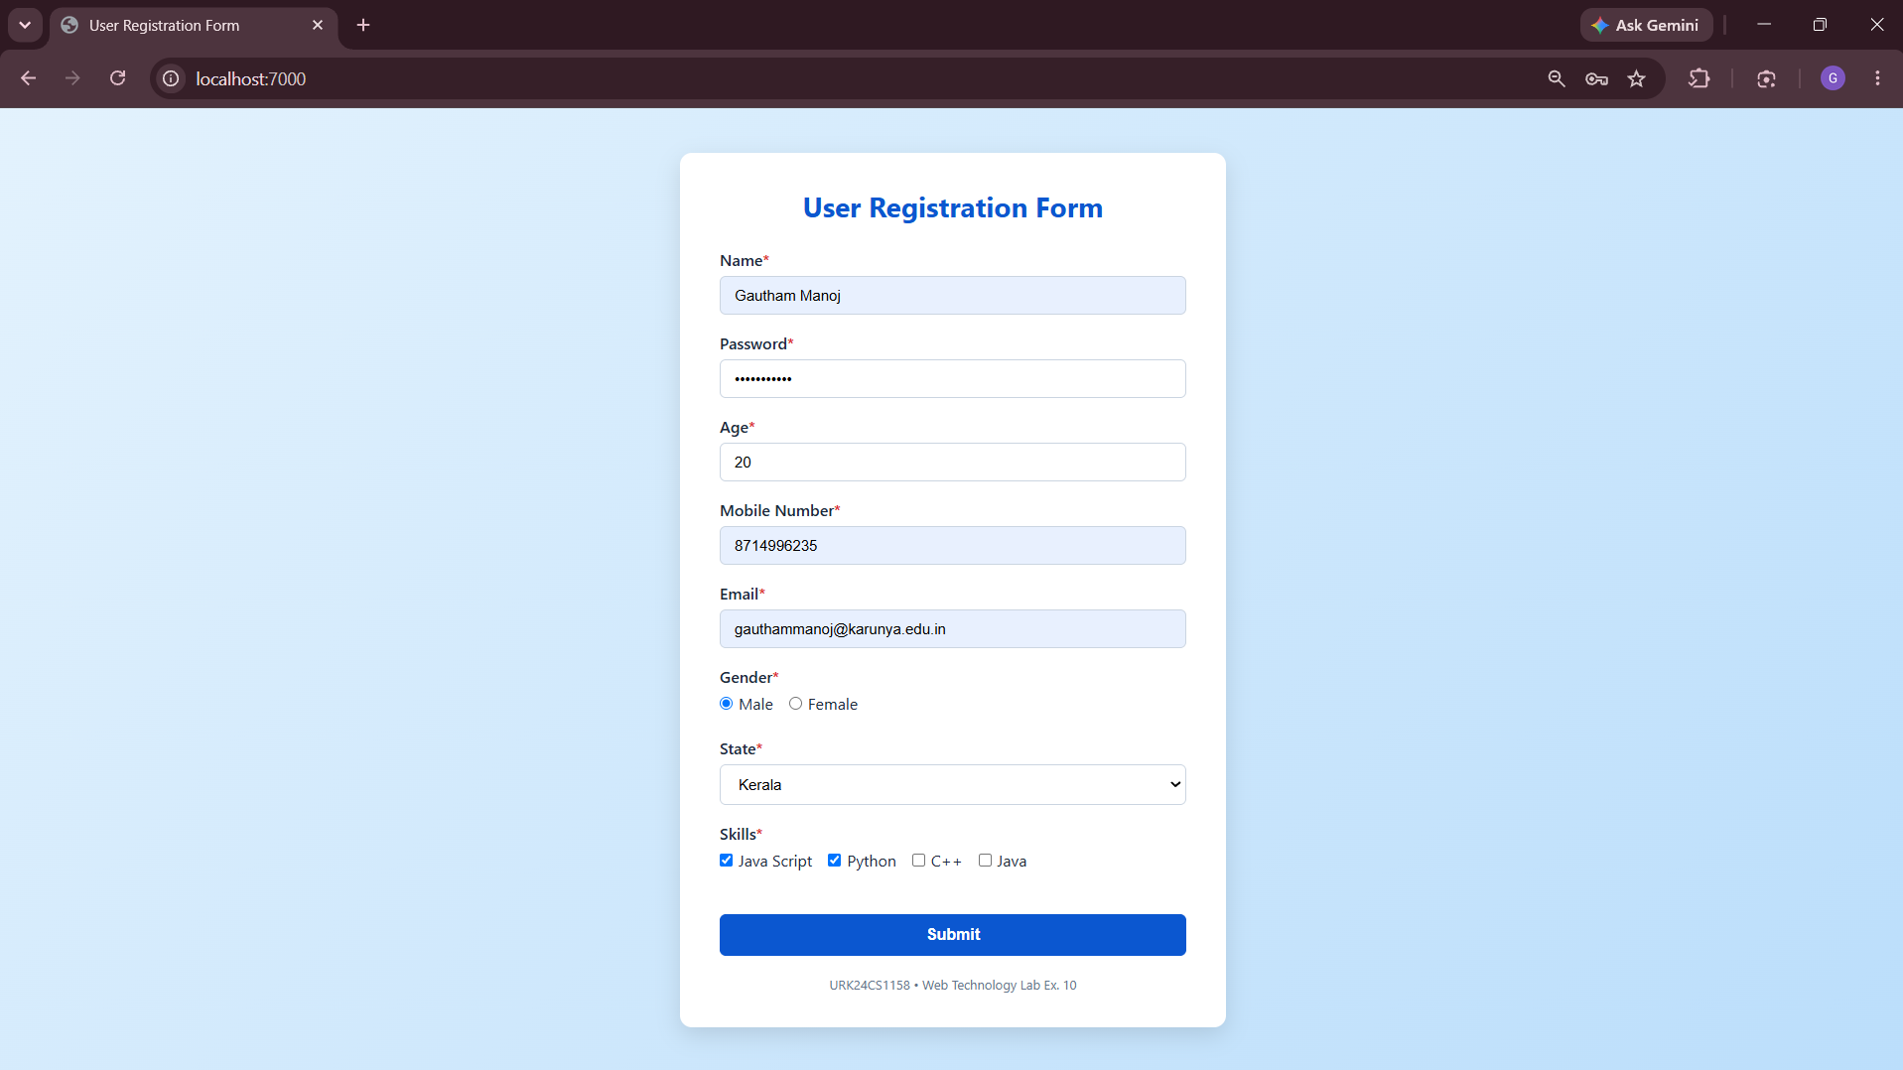

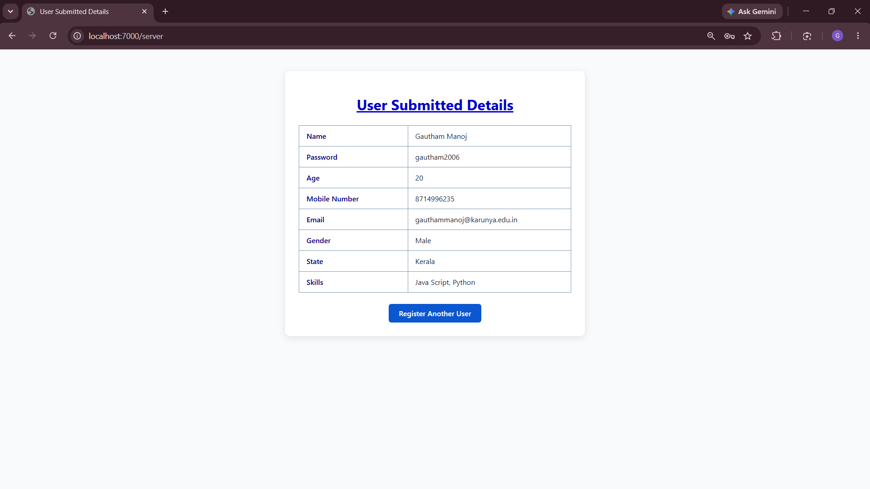

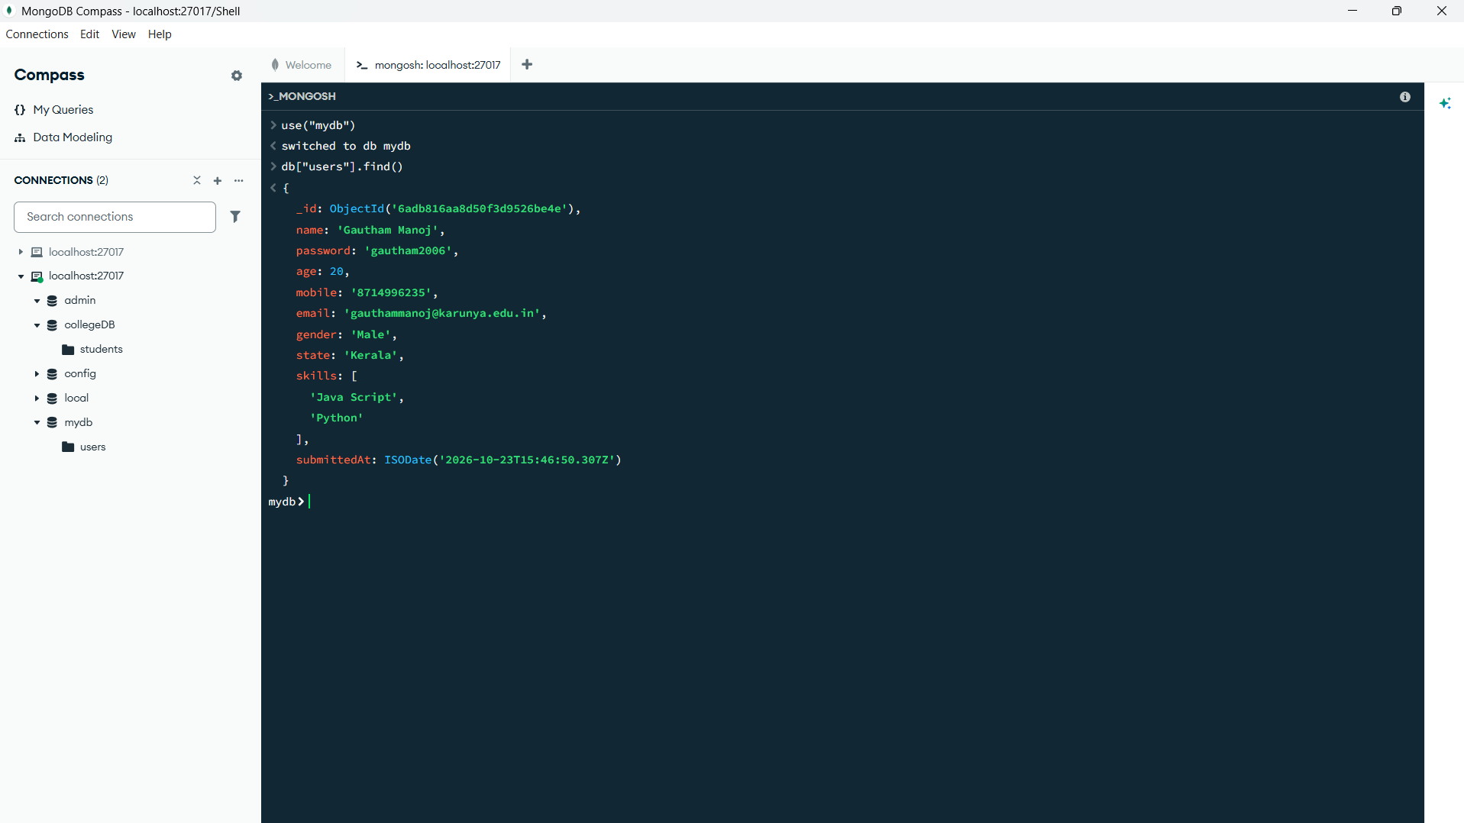

Result
Thus, a server-side application using Node.js and MongoDB was successfully developed to process user registration form details, store them in the database, and display the submitted information in a table format.

